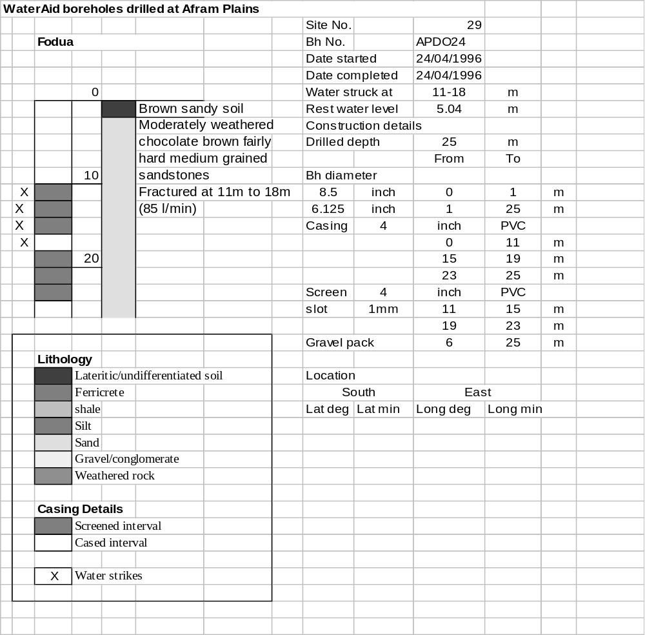

Ghana | Test pumping
Borehole No. |  | APDO24
Hole No |  | 29
Village |  | Fodua I
Date |  | 25/04/1996
Point above GL |  | 0.5 | m
Pump depth |  | 24 | m
SWL |  | 5.54 | m
Start Time |  | 10:05
Drawdown test |  |  |  |  | Recovery test
time | pwl (m) | Q l/min | dd (m) | sc | Time | wl (m) | s' (m) | t/t'
0.00 | 5.54 | 60.00 | 0.00 |  | 0.00 | 11.33 | 5.79
1.00 | 6.55 | 60.00 | 1.01 | 59.41 | 1.00 | 11.20 | 5.66 | 181.00
2.00 | 6.82 | 60.00 | 1.28 | 46.88 | 2.00 | 11.13 | 5.59 | 91.00
3.00 | 7.08 | 60.00 | 1.54 | 38.96 | 3.00 | 11.06 | 5.52 | 61.00
4.00 | 7.20 | 60.00 | 1.66 | 36.14 | 4.00 | 10.99 | 5.45 | 46.00
5.00 | 7.36 | 60.00 | 1.82 | 32.97 | 5.00 | 10.94 | 5.40 | 37.00
6.00 | 7.54 | 60.00 | 2.00 | 30.00 | 6.00 | 10.87 | 5.33 | 31.00
7.00 | 7.68 | 60.00 | 2.14 | 28.04 | 7.00 | 10.81 | 5.27 | 26.71
8.00 | 7.80 | 60.00 | 2.26 | 26.55 | 8.00 | 10.76 | 5.22 | 23.50
9.00 | 7.93 | 60.00 | 2.39 | 25.10 | 9.00 | 10.70 | 5.16 | 21.00
10.00 | 8.06 | 60.00 | 2.52 | 23.81 | 10.00 | 10.65 | 5.11 | 19.00
11.00 | 8.16 | 60.00 | 2.62 | 22.90 | 12.00 | 10.55 | 5.01 | 16.00
12.00 | 8.28 | 60.00 | 2.74 | 21.90 | 14.00 | 10.45 | 4.91 | 13.86
13.00 | 8.37 | 60.00 | 2.83 | 21.20 | 16.00 | 10.36 | 4.82 | 12.25
14.00 | 8.47 | 60.00 | 2.93 | 20.48 | 18.00 | 10.27 | 4.73 | 11.00
15.00 | 8.57 | 60.00 | 3.03 | 19.80 | 20.00 | 10.16 | 4.62 | 10.00
16.00 | 8.66 | 60.00 | 3.12 | 19.23 | 22.00 | 10.07 | 4.53 | 9.18
17.00 | 8.74 | 60.00 | 3.20 | 18.75 | 24.00 | 9.97 | 4.43 | 8.50
18.00 | 8.82 | 60.00 | 3.28 | 18.29 | 26.00 | 9.88 | 4.34 | 7.92
19.00 | 8.90 | 60.00 | 3.36 | 17.86 | 28.00 | 9.80 | 4.26 | 7.43
20.00 | 8.97 | 60.00 | 3.43 | 17.49 | 30.00 | 9.70 | 4.16 | 7.00
22.00 | 9.12 | 60.00 | 3.58 | 16.76 | 35.00 | 9.50 | 3.96 | 6.14
24.00 | 9.26 | 60.00 | 3.72 | 16.13 | 40.00 | 9.30 | 3.76 | 5.50
26.00 | 9.38 | 60.00 | 3.84 | 15.63 | 45.00 | 9.10 | 3.56 | 5.00
28.00 | 9.50 | 60.00 | 3.96 | 15.15 | 50.00 | 8.90 | 3.36 | 4.60
30.00 | 9.60 | 60.00 | 4.06 | 14.78 | 60.00 | 8.72 | 3.18 | 4.00
35.00 | 9.66 | 60.00 | 4.12 | 14.56 | 70.00 | 8.65 | 3.11 | 3.57
40.00 | 10.09 | 60.00 | 4.55 | 13.19 | 80.00 | 8.60 | 3.06 | 3.25
45.00 | 10.29 | 60.00 | 4.75 | 12.63 | 90.00 | 8.55 | 3.01 | 3.00
50.00 | 10.47 | 60.00 | 4.93 | 12.17 | 100.00 | 8.48 | 2.94 | 2.80
55.00 | 10.66 | 60.00 | 5.12 | 11.72 | 110.00 | 8.42 | 2.88 | 2.64
60.00 | 10.82 | 60.00 | 5.28 | 11.36 | 120.00 | 8.37 | 2.83 | 2.50
70.00 | 11.14 | 60.00 | 5.60 | 10.71
80.00 | 11.33 | 60.00 | 5.79 | 10.36
90.00 | 11.33 | 60.00 | 5.79 | 10.36
100.00 | 11.33 | 60.00 | 5.79 | 10.36
110.00 | 11.34 | 60.00 | 5.80 | 10.34
120.00 | 11.33 | 60.00 | 5.79 | 10.36
130.00 | 11.33 | 60.00 | 5.79 | 10.36
140.00 | 11.33 | 60.00 | 5.79 | 10.36
160.00 | 11.33 | 60.00 | 5.79 | 10.36
180.00 | 11.34 | 60.00 | 5.80 | 10.34
